Project Analysis Document

Version 3.0

Cinema Manager

Team 1

|  |  |
| --- | --- |
| Member Name | Roll number |
| Qandeel Mushtaq | 14-4087 |
| Zainab Iftikhar | 14-4304 |
| Aqsa Bajwa | 14-4251 |

**Table of Contents**

**1.** **Introduction** 1

**1.1** **Project Overview** 1

**1.2** **User Classes and Characteristics** 1

**2.** **Functionality Points** 1

Revision History

|  |  |  |  |
| --- | --- | --- | --- |
| **Name(s)** | **Date** | **Reason(s) For Change(s)** | **Version** |
|  |  |  |  |
|  |  |  |  |

# **Introduction**

This document that we are presenting you with is an attempt to explain the reader what a cyber cinema is and how it works, the functionalities it provides to its visitors, users and of course, the manager. “Picture Palace”, as the name suggests, organizes the tickets for the upcoming movies in our cinema and goes around on the same basis as any movie database goes, implemented by us on an undergraduate level.

## **Project Overview**

“Picture Palace” is a great site if you want to search for different movies playing in your free time and in your local area. It manages the cinema, its halls, the tickets, the bookings and movies’ schedules, everything related in one way; by online. You can reserve a seat online for yourself and your family, can be your friends too. A person booking for more than 5 seats will get 20% discount. Everything will be managed by us, all you have to do is just show up and buy popcorns for yourself.

Movie trailers will be available and users can read a review before finally making the decision of watching that movie.

## **User Classes and Characteristics**

“Picture Palace” is comprised of the following user classes:

1. Member
2. Visitor
3. Administrator

The functionalities of the users can be read from the tables below.

# **Functionality Points**

1. **Functionality 1 : Signup**

|  |  |
| --- | --- |
| **Signup** | |
| **User** | Visitor |
| **Steps** | |
| a) | A Visitor can sign up for this website by providing username, password, First name, last name, CNIC, credit card number, email id and contact number on signup.aspx page. |
| b). | If this Visitor name is already taken a message is shown "sorry, this user name already exists. Try another" |
| c). | In case the Visitor name is available, a new account is created and the new user Is redirected to his/her Home.aspx page. |
| **Assumptions** | username, password, First name, last name, CNIC will be not null, Contact number and Credit card number can be null |

1. **Functionality 2 : Login**

|  |  |
| --- | --- |
| **Login** | |
| **User** | Member |
| **Steps** | |
| a) | A Member can login to the website by providing username and password on login.aspx page. |
| b). | In case incorrect Member name or password is provided following message is shown "Incorrect user name or password" |
| c). | In case of correct username and password Member will be redirected to his/her Home.aspx page. |
| **Assumptions** | - |

1. **Functionality 2 : Login**

|  |  |
| --- | --- |
| **Login** | |
| **User** | Admin |
| **Steps** | |
| a) | Admin can login to the website by providing username and password on CinemaAdminlogin.aspx page |
| b) | In case incorrect user name or password is provided following message is shown "Incorrect user name or password" |
| c) | In case of correct username and password user will be redirected to his/her AdminHome.aspx page. |
| Assumptions | - |

1. **Functionality 3 : Search Movies**

|  |  |
| --- | --- |
| **Login** | |
| **User** | Member/ Visitor |
| **Steps** | |
| a) | Member can search for movies by using Search Box. This Search box will be on top of every page. |
| b). | Member can search the movies by lead actor or by genre. |
| **Assumptions** | - |

1. **Functionality 4 : Online Reservation**

|  |  |
| --- | --- |
| **Login** | |
| **User** | Member |
| **Steps** | |
| a). | Member can make online reservation after logging into his account on reservation.aspx page |
| b). | Seats will be reserved on CNIC. |
| c). | Member can pay through credit card. |
| **Assumptions** | Credit Card Number is given by the user while creating account on website. |

1. **Functionality 5: Adding Upcoming Movies**

|  |  |
| --- | --- |
| **Login** | |
| **User** | Admin |
| **Steps** | |
| a) | Admin can add upcoming movies on add movies.aspx page, by providing following information of the New movie:   * Name * Description * Lead Actors * Trailer (if available) |
| **Assumptions** | Name and description cannot be NULL. Trailer is added if link is available. |

1. **Functionality 6 : Block Users**

|  |  |
| --- | --- |
| **Login** | |
| **User** | Admin |
| **Steps** | |
| a). | Admin can block the user if the user violates the terms and privacy policy. |
| Assumptions | - |

1. **Functionality 7 : Review**

|  |  |
| --- | --- |
| **Login** | |
| **User** | Member |
| **Steps** | |
| a). | Member can give review of a movie. |
| b). | Member can also give a 5 star or below rating to the movie. |
| Assumptions | - |

1. **Functionality 8 : Rate**

|  |  |
| --- | --- |
| **Login** | |
| **User** | Visitor |
| **Steps** | |
| a). | Visitor can rate a review by clicking on thumbs up or thumbs down. |
| Assumptions | - |

1. **Functionality 9 : Discount**

|  |  |
| --- | --- |
| **Login** | |
| **User** | Member |
| **Steps** | |
| a). | Member can get a discount on a movie. |
| Assumptions | Discount will be given if a member makes more than 5 reservations. |

1. **Functionality 10 : Delete Review**

|  |  |
| --- | --- |
| **Login** | |
| **User** | Admin |
| **Steps** | |
| a). | Admin can delete review of any user. |
| Assumptions | - |

# **DATABASE DIAGRAM**

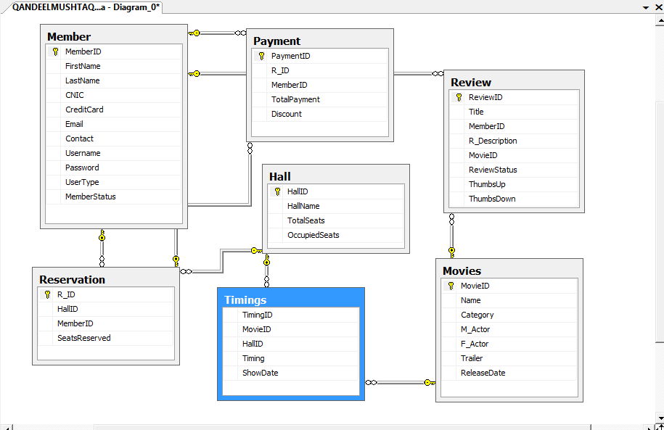

# **Back-End Implementation**

## **Procedures**

|  |  |
| --- | --- |
| **Procedure Name : Signup** | |
| **Functionality** | Signup |
| **Purpose :** Use to Signup new users | |
| **Inputs** | @FirstName varchar(30),  @LastName varchar(30),  @UserName varchar(30),  @password varchar(50),  @CNIC char(13),  @CreditCardNumber char(16),  @Email varchar (30),  @ContactNumber char (12) |
| **Output** | @status varchar(1) output, --return the status of signup 0 for fail 1 for success  @userid int output --return the userID of assigned to this new user |

|  |  |
| --- | --- |
| **Procedure Name : Login** | |
| **Functionality** | Login |
| **Purpose :** Use to Login users | |
| **Inputs** | @loginName varchar(30),  @password varchar(50), |
| **Output** | @status varchar(1)='' output,-- 1 for Success,2 for incorrect pswd, 3 for incorrect username  @userid int=0 output ,  @userType varchar(1)='' output |

|  |  |
| --- | --- |
| **Procedure Name : Movies Found** | |
| **Functionality** | Search Movies |
| **Purpose:** To show the result of the searched movies in tabular form. | |
| **Inputs** | @Attribute varchar(50) |
| **Outputs** | Movie ID, Name, Category, F_Actor, M_Actor, Trailer |

|  |  |
| --- | --- |
| **Procedure Name : Discount** | |
| **Functionality** | Discount |
| **Purpose :** To know whether member has to be given discount or not | |
| **Inputs** | @seats_reserved int |
| **Output** | @discount_approved bit OUTPUT --- 1 for discount given , 0 for no discount |

## **Views**

|  |  |
| --- | --- |
| **View Name : Show Information** | |
| **Functionality** |  |
| **Purpose:** To tell which movie is being played in which hall at certain time. | |
| **Columns** | Movie Name, Movie Category, F_Actor, M_Actor, HallID,  HallName, Timing |

|  |  |
| --- | --- |
| **View Name : Show Member** | |
| **Functionality** |  |
| **Purpose:** To show the details about member. | |
| **Columns** | First Name, Last Name, UserName |

|  |  |
| --- | --- |
| **View Name : Review** | |
| **Functionality** |  |
| **Purpose:** To show the details about reviews of member | |
| **Columns** | Title, Review Description |

## **Triggers**

|  |  |
| --- | --- |
| **Tigger Name: Seats Reserved** | |
| **Functionality** | Reservation |
| **Purpose:** If a user is blocked by admin we set it as blocked in table and don’t delete it. | |
| **Trigger type** | for |
| **DB Query** | DML(Update) |
| **Columns affected** | Seat Reserved (set to total seats reserved) |

|  |  |
| --- | --- |
| **Tigger Name: Delete Review** | |
| **Functionality** | Delete Review |
| **Purpose:** If a review is deleted by admin we set it as inactive in table and don’t delete it. | |
| **Trigger type** | instead of |
| **DB Query** | DML(Delete) |
| **Columns affected** | Review status (set to 0) |

|  |  |
| --- | --- |
| **Tigger Name: Block Member** | |
| **Functionality** | Block User |
| **Purpose:** | |
| **Trigger type** | instead of |
| **DB Query** | DML(Delete) |
| **Columns affected** | Member status (set to 0) |

|  |  |
| --- | --- |
| **Tigger Name: Suspend Account** | |
| **Functionality** |  |
| **Purpose:** If a user is blocked by admin we set suspend his account. | |
| **Trigger type** | instead of |
| **DB Query** | DML(Delete) |
| **Columns affected** | Account status (set to 0) |